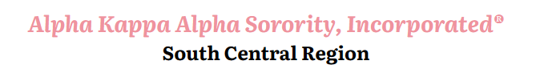

90th South Central Regional Conference Minutes Corrections Form

Email changes to: Cerise McClendon Martin, Regional Grammateus cerisemmartin@gmail.com
Copy email to: Lindsey Leverett-Higgins, Regional Anti-Grammateus lindseyleverett10@gmail.com

How it Currently Reads | Proposed Change | How It Will Read If Approved
Page Number _____________
Section __________

Sentence:

How it Currently Reads | Proposed Change | How It Will Read If Approved
Page Number ____________
Section _________

90th South Central Regional Conference Minutes Corrections Form

Email changes to: Cerise McClendon Martin, Regional Grammateus cerisemmartin@gmail.com
Copy email to: Lindsey Leverett-Higgins, Regional Anti-Grammateus lindseyleverett10@gmail.com

How it Currently Reads | Proposed Change | How It Will Read If Approved
Page Number _____________
Section __________________

Sentence:

How it Currently Reads | Proposed Change | How It Will Read If Approved
Page Number _____________
Section __________________

Sentence:

